1. FB50 – Gratuity Trust Accounting
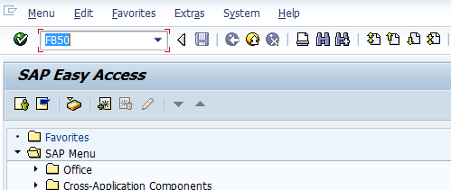
- Input FB50 in Transaction box and press Enter key

1.1 Document Header Data Information
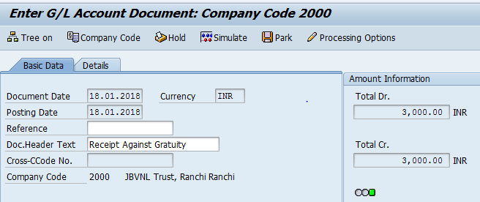
The following are the Input fields under the Document Header data
- Document Date: Input the Invoice date in the Document date field
- Posting Date: Input the transaction date in the Posting date field
- Currency: Input the Currency INR in the Currency field
- Document Header Text: Input the Text Information in text field

1.2 Document Line Item Data
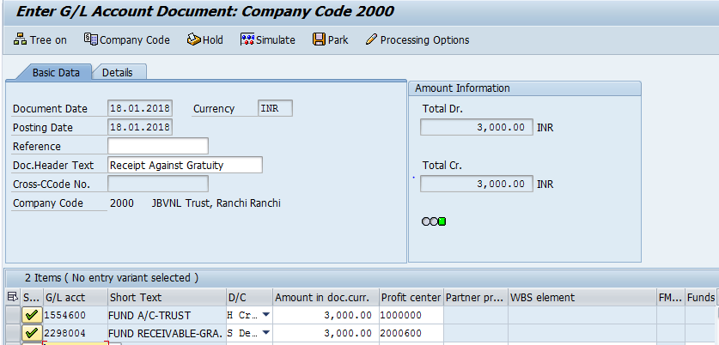
The following are the Input fields under the Line Item data
- GL Account: Place the Cursor on the field and press F4. Select the respective GL Account and press Enter key
- Debit/Credit: Select Debit/Credit option from drop down list
- Text Field: Input the Text information
- Profit Center: Place the cursor on the field and press F4. Select the respective Profit Center and press Enter key

1.3 Simulate
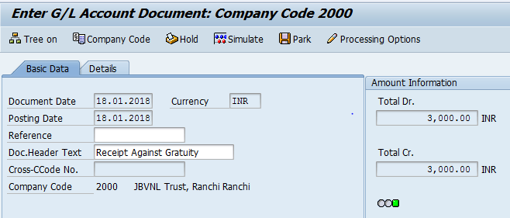
Simulate: Click on Simulate option. System will display the line items (Debit and Credit entry).
- Check the entries, if the entries are correct, click on Post option
- If the entries are wrong then go to Main screen and change the line items.
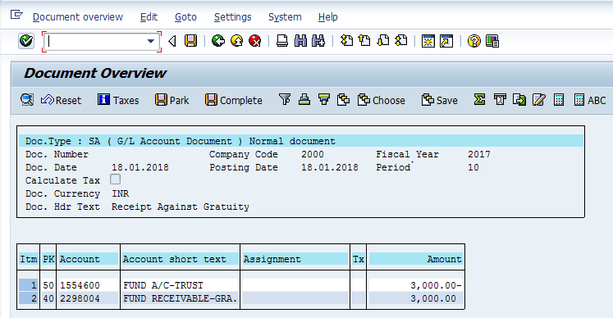

1.4 Document Posting
- Document Posted in company code 1000 will pop up at the bottom of the screen

1.5 Document Display View
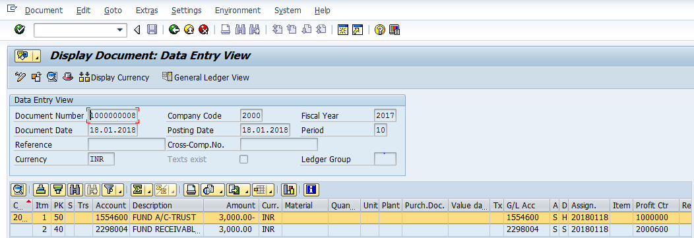
- Display Document: From Menu bar select Document option it will display the options Change, Display, Post and Save as completed. Choose Display option. Document successfully got posted will get displayed or It can be displayed in TC FB03.

2. Payment to the Trust Company

2.1 Document Header Data Information
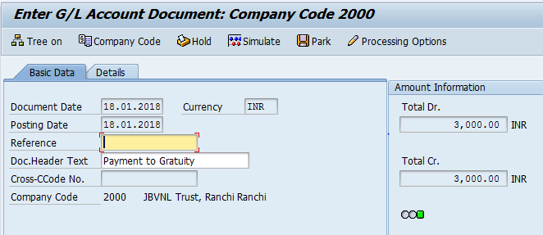
The following are the Input fields under the Document Header data
- Document Date: Input the Invoice date in the Document date field
- Posting Date: Input the transaction date in the Posting date field
- Currency: Input the Currency INR in the Currency field
- Document Header Text: Input the Text Information in text field

2.2 Document Line Item Data
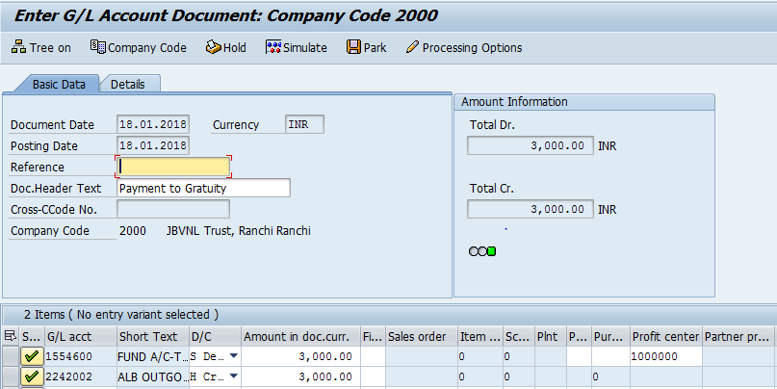
The following are the Input fields under the Line Item data
- GL Account: Place the Cursor on the field and press F4. Select the respective GL Account and press Enter key
- Debit/Credit: Select Debit/Credit option from drop down list
- Text Field: Input the Text information Eg: Payment to Trust
- Profit Center: Place the cursor on the field and press F4. Select the respective Profit Center and press Enter key

3.3 Simulate
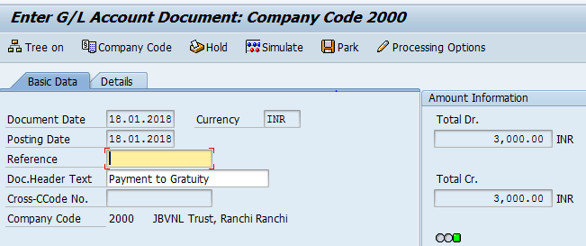
Simulate: Click on Simulate option. System will display the line items (Debit and Credit entry).
- Check the entries, if the entries are correct, click on Post option
- If the entries are wrong then go to Main screen and change the line items.
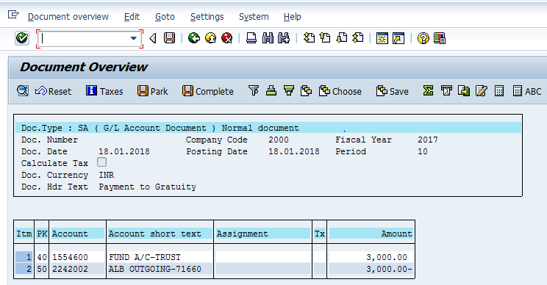

2.4 Document Posting
- Document Posted in company code 2000 will pop up at the bottom of the screen

2.5 Document Display View
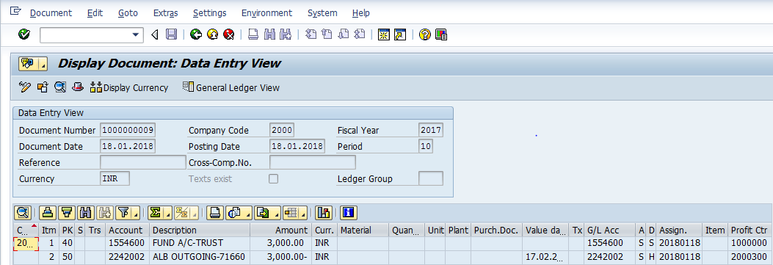
- Display Document: From Menu bar select Document option it will display the options Change, Display, Post and Save as completed. Choose Display option. Document successfully got posted will get displayed or It can be displayed in TC FB03.

Manual End

